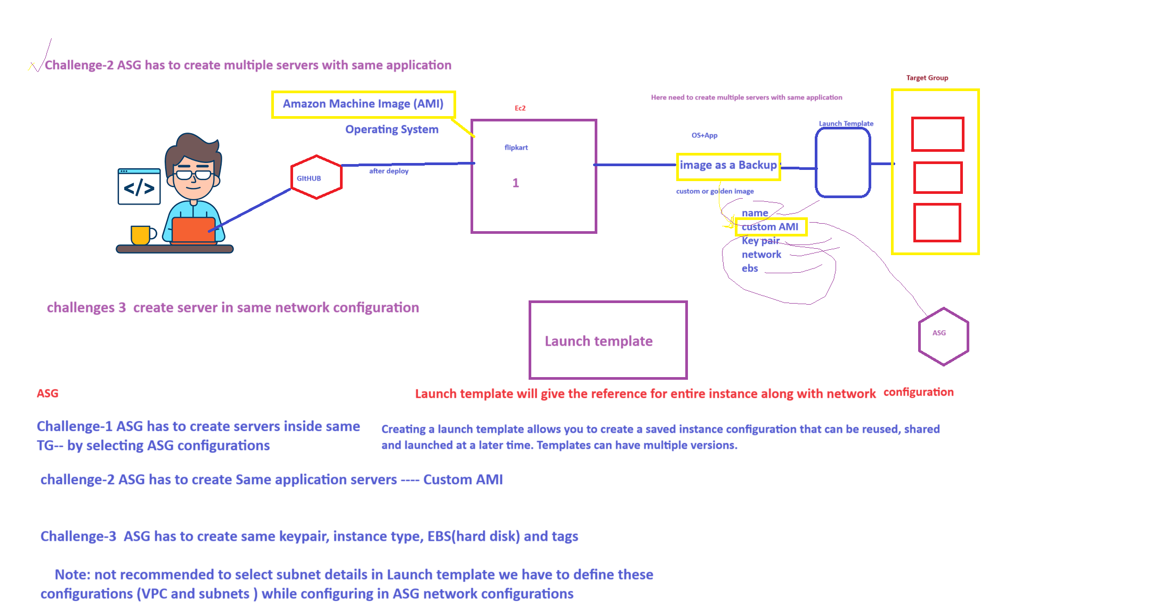

For challenging -2 is not a good practice because any update of application will come, so we need to delete present server and we need to create again custom(backup) image.

So to avoid this the Ansible concept comes into picture

By using ansible we can do all same updates for all servers without deleting.

Ansible is a configuration tool.

ASG

Target group

AMI custom or golden (image as backup os+application)

Launch template.